Verify login with Invalid data(Password)

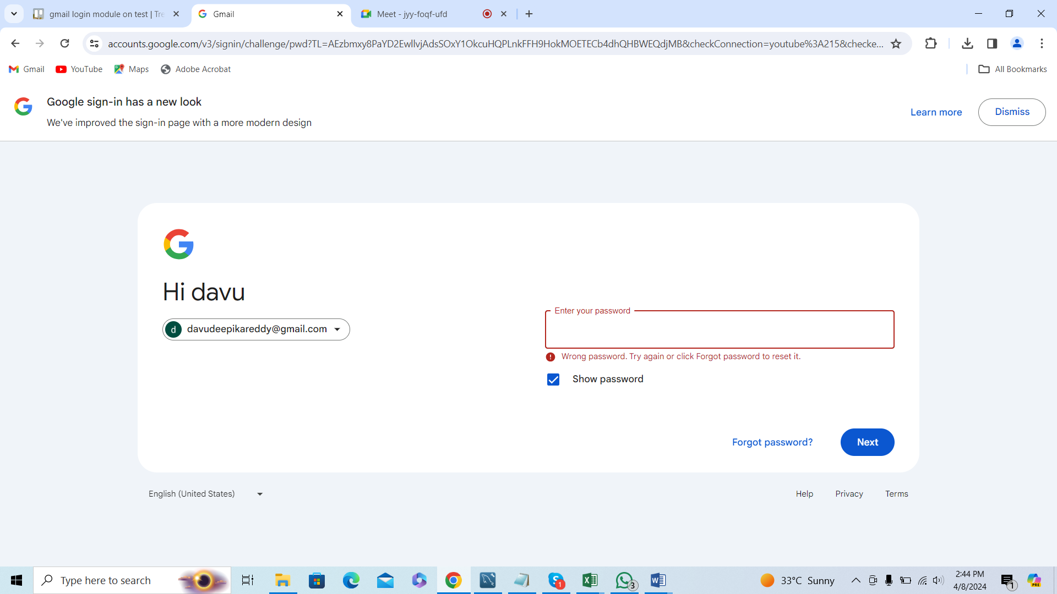

Error message is displayed